**User Guide for Eclipse-based Manufacturing Tool Plug-in**

**Supports**

**i.MX6**

Table of Contents

Overview 3

Supported/Tested i.MX6 Profiles 3

Things to Keep in Mind 3

Supported/Tested Versions of Eclipse 4

PC Requirement 5

File Structures in Eclipse Plug-in 6

How to Create a XML File 7

Setting the VID/PID of XML File 7

Structure of XML List 7

Starting the Application for the First Time 8

Before opening the Eclipse Application 8

Opening the Manufacturing Tool 9

Opening and Closing Views 12

Manufacturing Tool Views 15

Loading an Image onto the Board 16

Different Modes 16

Steps to Begin the Loading Process 16

During the Loading Process 19

Error Messages 20

Obtaining the PID/VID of Devices 22

Device Connected as HID 22

Device Connected as USB Mass Storage Device 25

# Overview

This document is prepared for factory operations and describes how to correctly use the Eclipse manufacturing tool environment.

# Supported/Tested i.MX6 Profiles

* MX6DL
* MX6Q
* MX6SL

# Things to Keep in Mind

* If the C/C++ Developers edition of Eclipse is going to be used, the following instructions must be followed:

1. Download the C/C++ Developers edition of Eclipse + Java Developers edition of Eclipse
2. Copy the Manufacturing Tool .jar file into the plugins folder in Java Developers edition
3. Copy the contents of the plugins folder in Java Developers edition
4. Paste the copied files from Step 3 into the plugins folder of the C/C++ Developers edition

# Supported/Tested Versions of Eclipse

|  |  |
| --- | --- |
| Compatible | Not Compatible |

|  |  |  |  |
| --- | --- | --- | --- |
| Platform Name | Platform Version | Package | Support |
| Indigo | 3.7 | Java EE Developers | YES |
| Java Developers | YES |
| C/C++ Developers | YES |
| JavaScript Web Developers | YES |
| Modeling Tools | YES |
| RCP and RAP Developers | YES |
| Java and Report Developers | YES |
| Testers | NO |
| Parallel Application Developers | YES |
| Scout Developers | YES |
| Classic | Not Found |
| Juno | 4.2 | Java EE Developers | YES |
| Java Developers | YES |
| C/C++ Developers | YES |
| Mobile Developers | YES |
| Modeling Tools | YES |
| RCP and RAP Developers | YES |
| Java and Report Developers | YES |
| Parallel Application Developers | YES |
| Testers | NO |
| Automative Software Developers | YES |
| Scout Developers | YES |
| Kepler | 4.3 | Java EE Developers | YES |
| Java Developers | YES |
| C/C++ Developers | YES |
| Java and DSL Developers | YES |
| Modeling Tools | YES |
| RCP and RAP Developers | YES |
| Java and Report Developers | YES |
| Parallel Application Developers | YES |
| Automative Software Developers | YES |
| Scout Developers | YES |
| Testers | NO |
| Standard | YES |

**Note: Eclipse versions released before 3.7 (Indigo) are not supported by the Eclipse Manufacturing Tool plug-in.**

# PC Requirement

* **CPU:** Intel E3400 or higher, Frequency: 2GHz+
* **Memory:** 4GB+
* **OS:** Windows XP/Windows 7 version
* **USB 3.0/2.0 root hub is a must,** NO USB 1.1 root hub is allowed

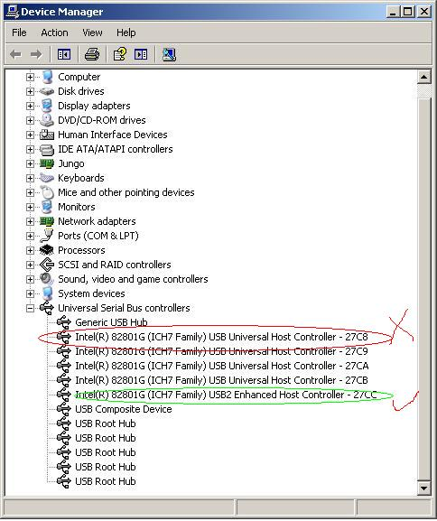

* **External USB hub is allowed with restrictions below:**
  + **Must use independent power supply**
  + **Must pass the compliance test of USB org, Belkin USB hub is recommended**
  + **No more than 4 devices are allowed to be connected to the USB hub**

# File Structures in Eclipse Plug-in

Following is an example of a typical file structure that the Eclipse plug-in recognizes.

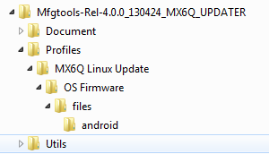

Once loaded inside Eclipse, the file structure looks something like the following:

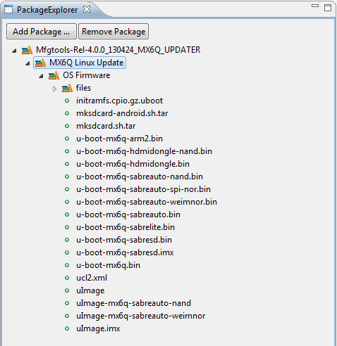

Notice the location of the ucl2.xml file. This is the main source of executable commands that the boards read in. It is important that the .xml file is placed in a similar file structure as shown above.

# How to Create a XML File

### Setting the VID/PID of XML File

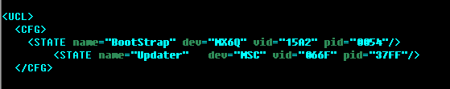

Follow the format represented above replacing the vid and pid with appropriate values.

**Note: Specific profiles only work with their specific boards determined by the PID/VID in the .xml files. If the boards PID/VID do not match the specifications from the .xml file, then the board will not be recognized by the plug-in.**

### Structure of XML List

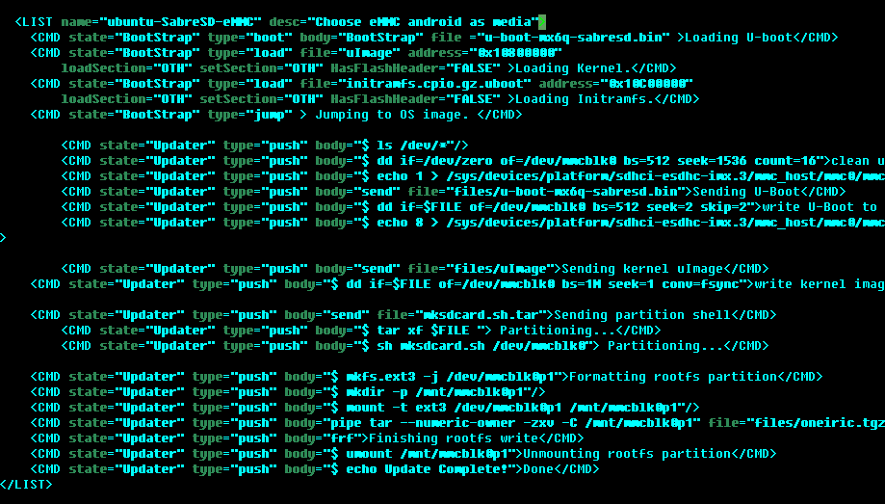

**Notice the structure of the List and CMD values. All XML files must follow a similar format for the Eclipse manufacturing Tool to recognize the content.**

**Note: The Eclipse Manufacturing Tool does not support any & symbols inside the XML files. Therefore, replace all & symbols with “and” inside each XML file that is used.**

**Note: The entire XML file should begin with <UCL> and end with </UCL>.**

# Starting the Application for the First Time

**Note: All images captured are from Eclipse 3.7 (Indigo) java developers version. Different versions could have additional steps and/or views.**

### Before opening the Eclipse Application

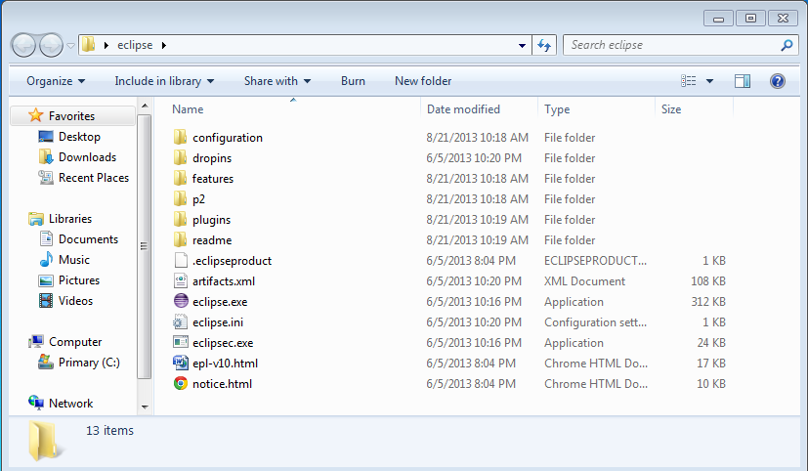

Open this Plugins folder

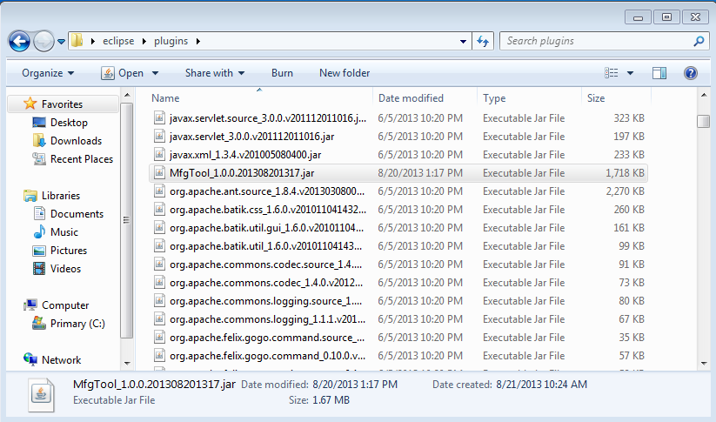

Eclipse Manufacturing Tool .jar file

Copy the ManufacturingTool.jar file into the ‘plugins’ folder located inside the directory from which the eclipse application runs.

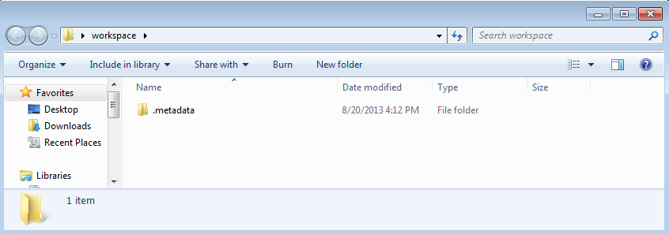

Locate the workspace that is going to be used for this Eclipse Plug-in and delete the .metadata folder.

### Opening the Manufacturing Tool

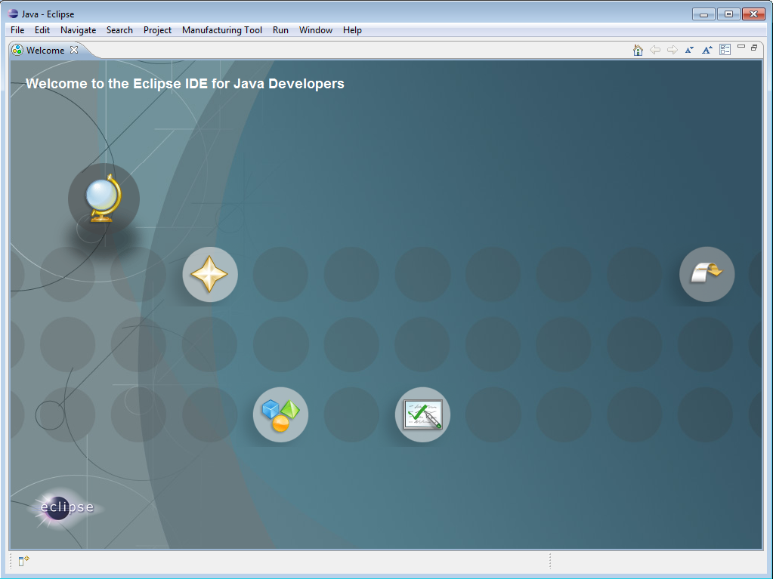

Open the Eclipse Application

File 🡪 New 🡪 Other

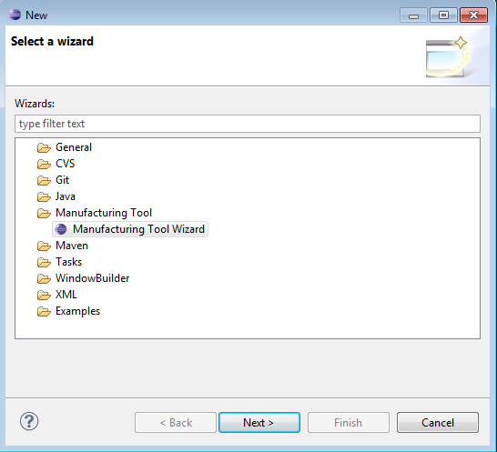

Manufacturing Tool 🡪 Manufacturing Tool Wizard. Click Next.

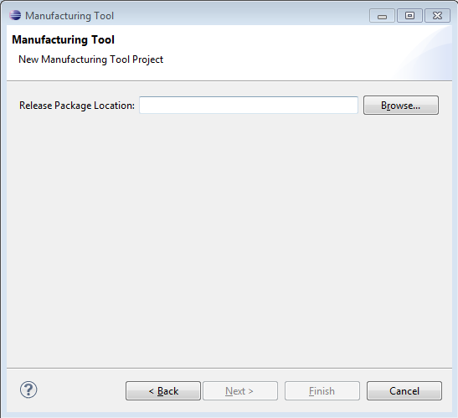

Click Browse.

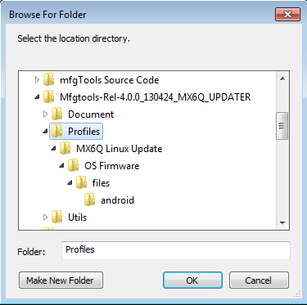

Select the “Profiles” folder located inside the release. Click Ok.

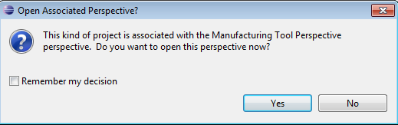

Select Yes.

### Opening and Closing Views

To close a view at any given time, simply X out the view. To reopen views, read below.

**Create a new project**

**Open Perspective**

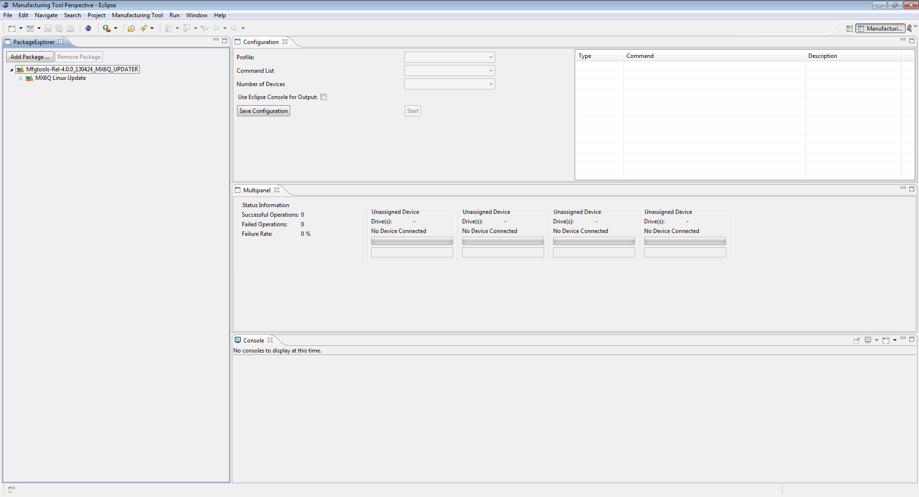

**CONFIGURATION**

**MULTIPANEL**

**XML Code**

**CONSOLE**

**PACKAGE EXPLORER**

To open the console view, go to Window 🡪 Show View 🡪 Other

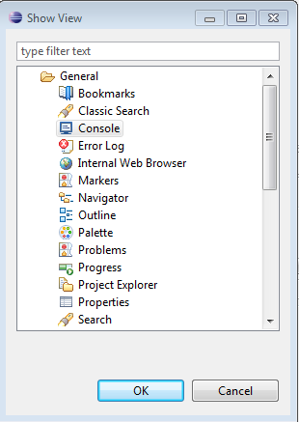

Select General 🡪 Console. Click Ok. The console window should populate on the main screen.

To open the Package Explorer, Configuration, or Multipanel views, go to Window 🡪 Show View 🡪 Other

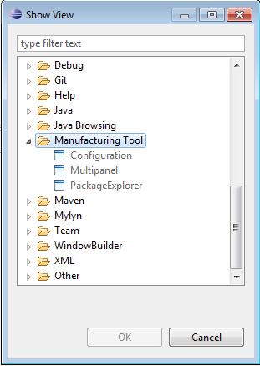

Drop down into Manufacturing Tool. Select the view that would like to be brought up. Click Ok. Any of the three views may be opened from this window.

To open the perspective, go to Window 🡪 Open Perspective 🡪 Other. Alternatively, click the button in the top right corner to open perspectives.

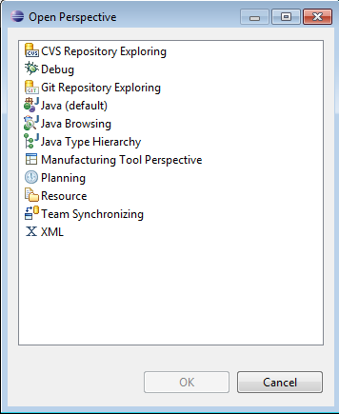

**Select this perspective**

Select Manufacturing Tool Perspective. Click Ok.

### Manufacturing Tool Views

**Create a new project:** Simply click on the small eclipse logo. Alternatively, click Manufacturing Tool 🡪 Start Manufacturing Tool.

* If no profiles are currently open in the Package Explorer, creating a new project will simply add a new profile into the Package Explorer.
* If 1 or more profiles exist in the Package Explorer, all of the profiles will be **REPLACED** by the single profile that is added by creating a new project.

**Package Explorer:** Enables the user to import different profiles into the plug-in from various locations of the file system. The package explorer will save the imported profiles after the plug-in is closed for future use.

* Add Package – add an additional package from the file explorer into the Eclipse plug-in.
* Remove Package – remove a package/profile from the Eclipse plug-in.
  + **Note: Removing a package from this plug-in will not delete the profile in the file system.**

**Configuration:** Allows the user to select the profile, command list, number of devices connected, and whether or not to use the console within the plug-in.

* Profile – the selected package from the package explorer is the profile. Contains the release materials.
* Command List –all executable commands in a XML file sorted out in a list, varying for different purposes
* Number of Devices – currently support connection of 1-4 devices. All devices will load the same image onto the board per cycle.
* Console for Output – Provide a console for serial output from the connected board.
* Save configuration – save any changes made and enable the next stage of the plug-in to load the image onto the board.
* XML Code (labeled on diagram above) – shows the current XML commands that are going to be executed under the selected command list. The list of XML commands changes as different command lists are selected.

**Multipanel:** Shows the current progress of the devices connected along with the status information.

# Loading an Image onto the Board

### Different Modes



There is no device connected. This message could also occur if the PID/VID do not match between the board(s) and the .XML file. See “How to Create a XML File” for more help.

The device is seen as a HID (Human Interface Device) by the application. This is mode required to begin loading an image onto the board.



The device is seen as a USB Mass Storage Device. This mode commonly comes up during the loading process.

The device is disconnected. There is no device connected to this port.

### Steps to Begin the Loading Process

1. Select one item from each of the dropdown lists in the Configuration Panel.
2. Check the checkbox if the user wants the console embedded into Eclipse. Skip step 4 if console is not embedded into Eclipse.
3. Click “Save Configuration”
4. In the multipanel view, click “Scan Ports” and select a CommPort from the dropdown list to the left of the button. If no console window was previously open, a new one should open up. Otherwise, within the console window, the new CommPort view should load.
5. Click “Start” in the configuration panel.

#### Configuration

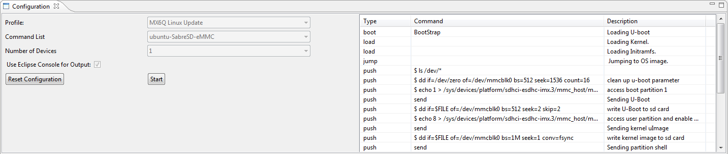

The configuration panel looks like the view above once all of the dropdown fields have been selected and “Save Configuration” button has been pressed. The current XML code for this particular item in the command list is also shown on the right half of the Configuration panel.

* Reset Configuration – Allows the user to reset all of the configurations that have been set. During this time the user is not able to load any image onto the board(s).
* Start – Button that allows the user to start the operation. Button will become Pause once the operation has started.

**Note: It is the user’s responsibility to pick the correct command list item to load onto the board. The current Manufacturing Tool has no way of detecting which command list item is associated with which board.**

**Note: Once the user has saved a configuration, the user will not be allowed to remove or change the current profile that they are using unless they reset the configuration. However, a new profile can always be added to the package explorer by clicking “Add Package.”**

#### Multipanel

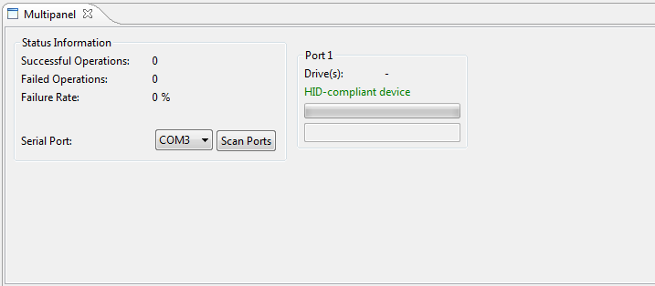

The multipanel shows an additional component once the checkbox for “Use Eclipse Console for Output” is selected. Additionally, the current devices connected are represented on the right half of the image above showing the port name and current state in which the board is connected.

* Scan Ports – Allows the user to scan through all of the current CommPorts that exist for serial communication with the board(s). The dropdown list to the left of the button shows all of the CommPorts that have been found. Selecting any CommPort on the list opens up the console (if it was not already opened) and shows the output of the current CommPort. The user may switch between CommPorts by simply selecting another item from the dropdown list.

**Note: The “Scan Ports” button and dropdown list will not be visible on the panel if the checkbox is not checked in the configuration panel to enable the embedded console.**

#### Console

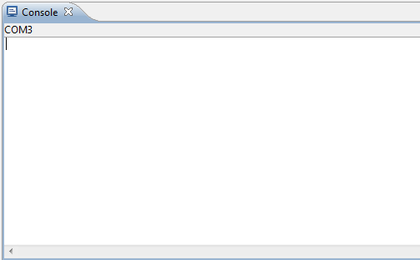

**Current CommPort shown in view**

The console view is currently showing that COM3 is being shown inside this panel. Selecting a different CommPort from the dropdown list in the multipanel will cause COM3 to change to whatever CommPort is selected.

### During the Loading Process

#### Handling USB Mass Storage Device

Once the USB Mass Storage Device is detected, windows will pop up a new window.

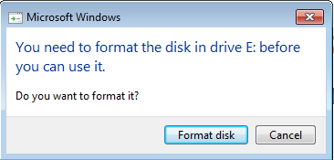

Click Cancel.

#### Configuration

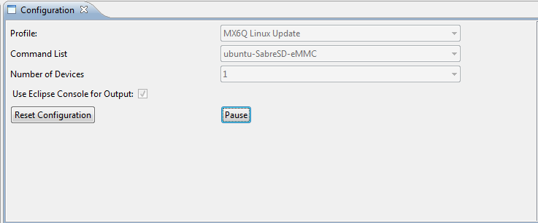

* Pause – Pauses the current operation. Pauses will occur after executing the current command.
* Reset Configuration – Resets the current configuration selected.

#### Multipanel

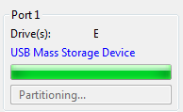

In the multipanel view, there is also a progress bar showing the current status of each command that is being passed to the board along with the current operation that is taking place written below the progress bar.

# Error Messages

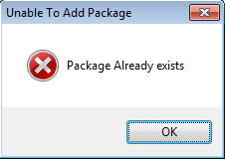

This error is generated when an existing package is added again.

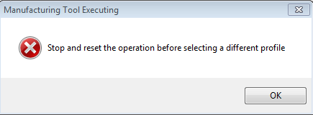

This error is generated when the user attempts to change the current profile they are using in the package explorer while there is a saved configuration in progress.

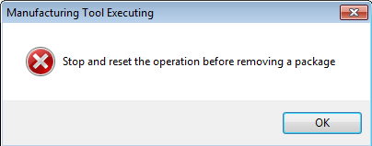

This error is generated when the user attempts to remove a profile from the package explorer while there is a saved configuration in progress.

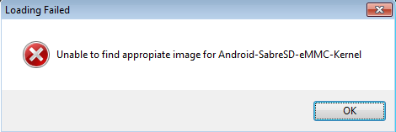

This error is generated when an invalid command list is selected.

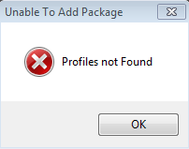

If an invalid package is added.

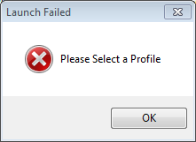

If no Profile is selected in the configuration panel.

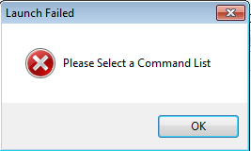

If no command list is selected in the configuration panel.

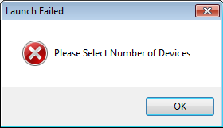

If the number of devices are not selected in the configuration panel.

# Obtaining the PID/VID of Devices

### Device Connected as HID

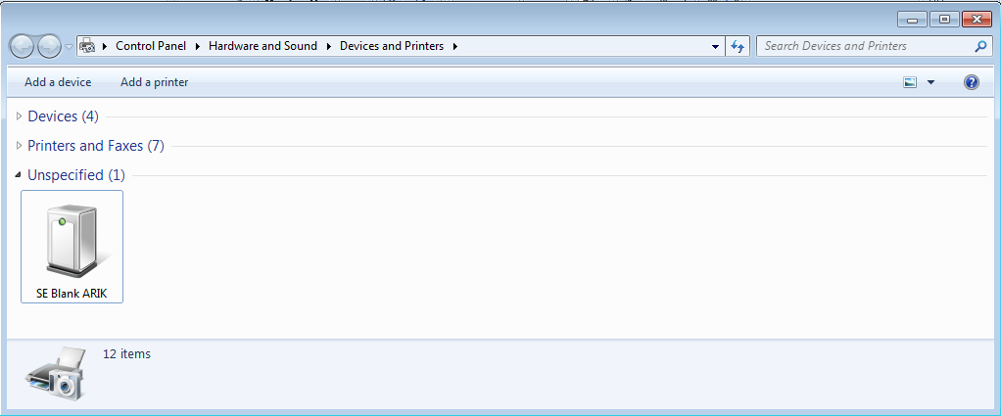

Open Devices and Printers located under:

Start 🡪 Control Panel 🡪 Hardware and Sound 🡪 Devices and Printers

Under Unspecified, the devices will appear. Right click on the device that you would like to see the PID/VID for and select Properties.

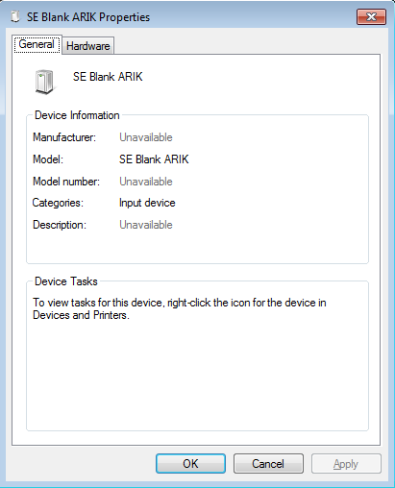

Select Hardware.

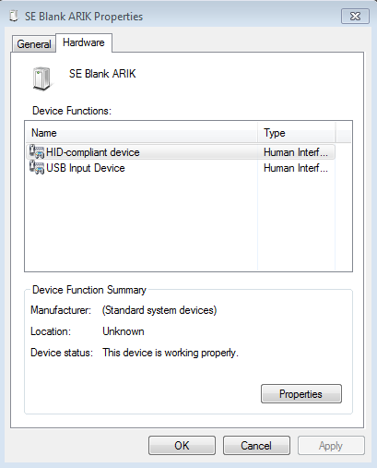

Select HID-compliant device. Click Properties.

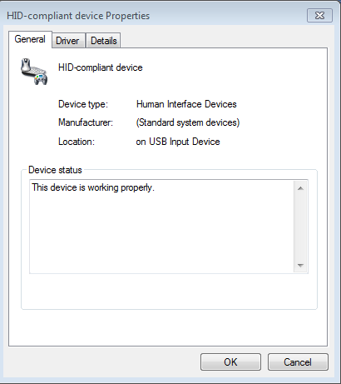

Select Details.

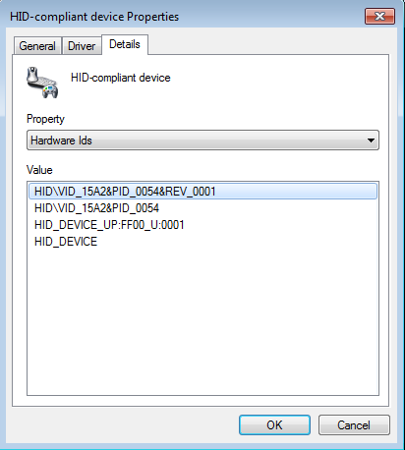

Under the Property dropdown menu, select Hardware Ids. Listed in the Value window are PID and VID for the device selected.

### Device Connected as USB Mass Storage Device

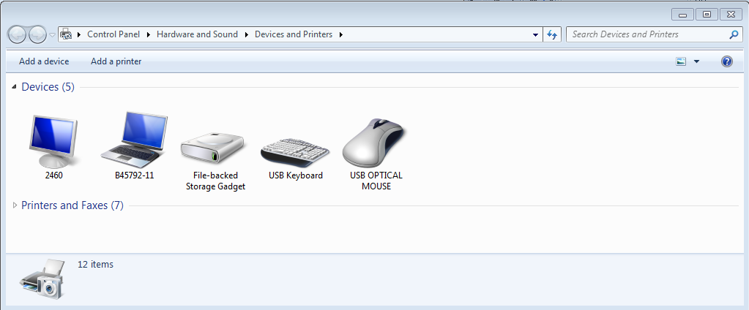

Open Devices and Printers located under:

Start 🡪 Control Panel 🡪 Hardware and Sound 🡪 Devices and Printers

Under “Devices,” the connected devices will appear. In this case, the device is titled “File-backed Storage Gadget.” Right click on the device that you would like to see the PID/VID for and select Properties.

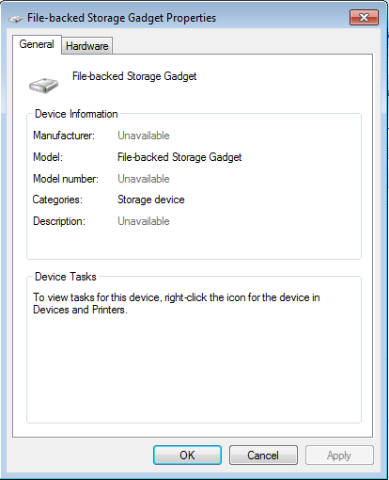

Select Hardware.

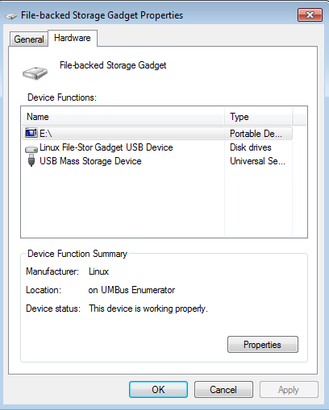

Select USB Mass Storage Device. Click Properties.

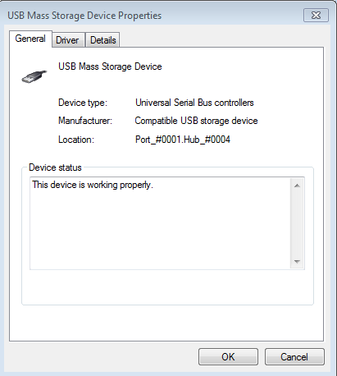

Select Details.

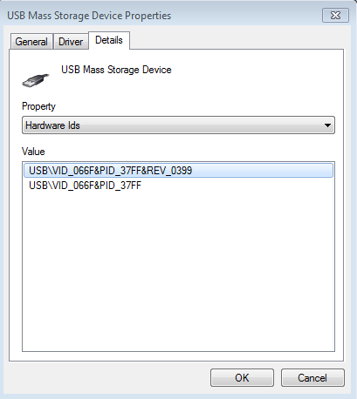

Under the Property dropdown menu, select Hardware Ids. The PID/VID are listed inside the Value window.



